# Compensation of Nonlinearities of the Voltage Source Inverters for High Precision Position Control Applications

Progressive Report Fall 2018

Hüseyin YÜRÜK

Table of Contents

[Compensation of Nonlinearities of the Voltage Source Inverters for High Precision Position Control Applications 1](#_Toc533204423)

[Problem Definition: 3](#_Toc533204424)

[Nonlinearities 3](#_Toc533204425)

[Experimental works 5](#_Toc533204426)

[Observation of current harmonics due to nonlinear effects 5](#_Toc533204427)

[Observation of relation between switching frequency fsw and nonlinearities 8](#_Toc533204428)

[Determination of f(id) to get Ud in MATLAB 10](#_Toc533204429)

[Compensation of nonlinearity by using look up table of Id vs Ud graph in Simulink 12](#_Toc533204430)

[Experimental results of the compensation of nonlinearity 16](#_Toc533204431)

[Difficulties to get f(id) for compensating nonlinearities 18](#_Toc533204432)

[How to increase current control bandwidth without compensation of nonlinearities 19](#_Toc533204433)

[High bandwidth current control by using GaN transistor based VSI 21](#_Toc533204434)

[Overview of the GaN transistor based VSI (BOOSTXL-3PHGANINV) ti design 21](#_Toc533204435)

[Measurements with the GAN transistor based VSI (BOOSTXL-3PHGANINV) 22](#_Toc533204436)

[Current control bandwidth measurements of the GAN transistor based VSI (BOOSTXL-3PHGANINV) 22](#_Toc533204437)

[Future plan 26](#_Toc533204438)

## Problem Definition:

Following nonlinearities cause distortion on the output voltage of the VSI

* dead-time
* switching time
* delay time
* voltage drops on the power switch and the freewheeling diode
* parasitic capacitance of the power switch

Output voltage distortion causes

* low order harmonic components in the output current of the inverter
* deformation of the phase currents, especially in the current zero-crossing region
  + these distortions
    - effects the control performance of the applications that require low speed & low torque
    - degrades the efficiency and increases the torque ripple

### Nonlinearities

Three phase PWM VSI with a PMSM load and ideal and actual output voltages.

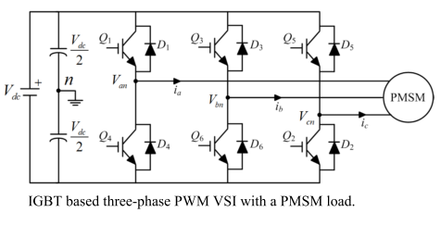

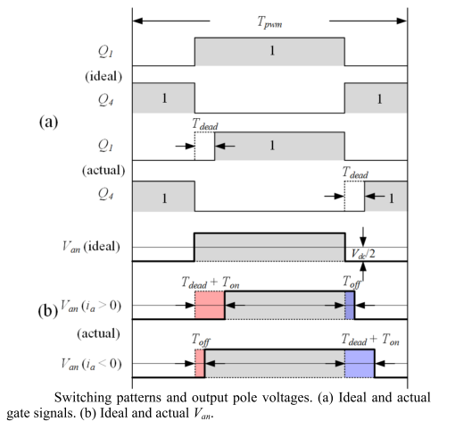 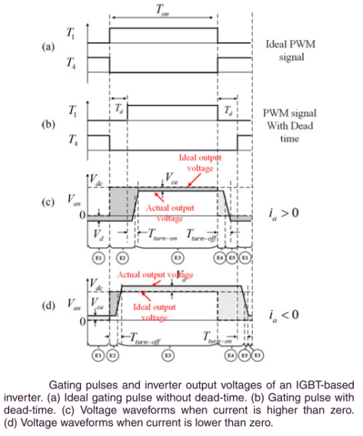

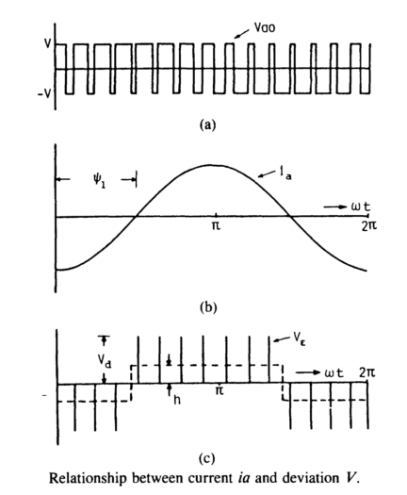

VƐ = Vao – Va

VƐ = Vd \* tdead  (in simple way)

h \* To/2 = (fs / fo) / 2 \* VƐ

h = fs \* VƐ

* so as fs ↗ distortion also ↗
* effect of the distortion gets more severe when
  + output frequency fo is low & output magnitude is low
  + iron and core losses and torque ripple increases

Analysis demonstrates that the nonlinear effects mainly produce 5th and 7th harmonics in the α-β reference frame and 6th voltage harmonic and its multiples in the d-q reference frame which cause current harmonics

## Experimental works

### Observation of current harmonics due to nonlinear effects

To observe current harmonics in the phase current and also in the d-q reference frame currents, an air cored (ironless winding) low inductance servo motor is driven by MOSFET based PWM VSI inverter at open loop.

#### Motor parameters:

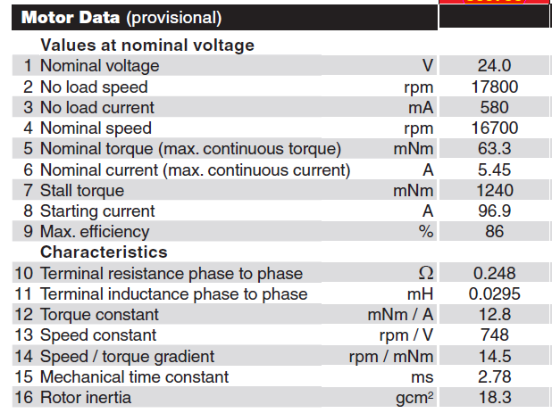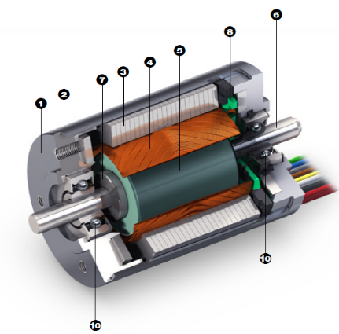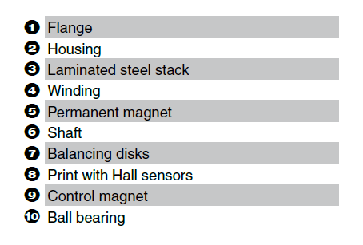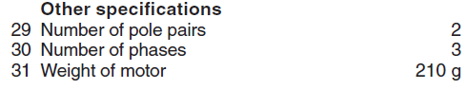

#### VSI inverter parameters:

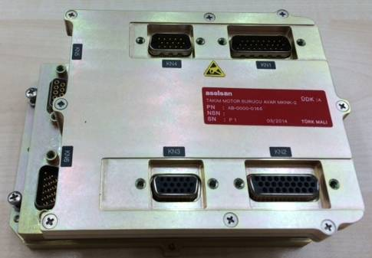

* AVAR servo driver (REHİS-MMTM design)
  + Input voltage 18-50VDC
  + 5Arms output current
  + Resolver, QEP, Hall, Abs Encoder feedback
  + CAN, RS422, Ethernet communication
  + ΔΣ phase current sensing
  + MOSFET (SUM90N10), gate driver (IRS2336D)
  + TMS320F28235 DSP

#### Measurements

Motor is driven *open-loop**by* sinusoidal pulse width modulation (SPWM) at @10Hz reference speed & @switching frequency (fsw) 20kHz.

Note that graphs,

* for speed, 1cnt 🡪 0.5Hz
* for current, 1cnt 🡪 0.25mA

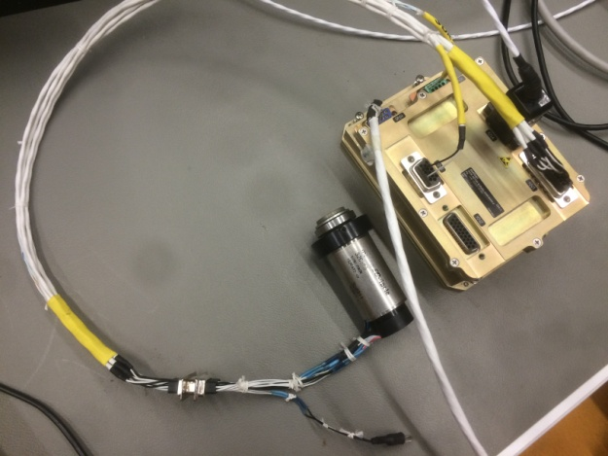

Figure 1 experimental setup to observe current harmonics in the phase current and also in the d-q reference frame currents

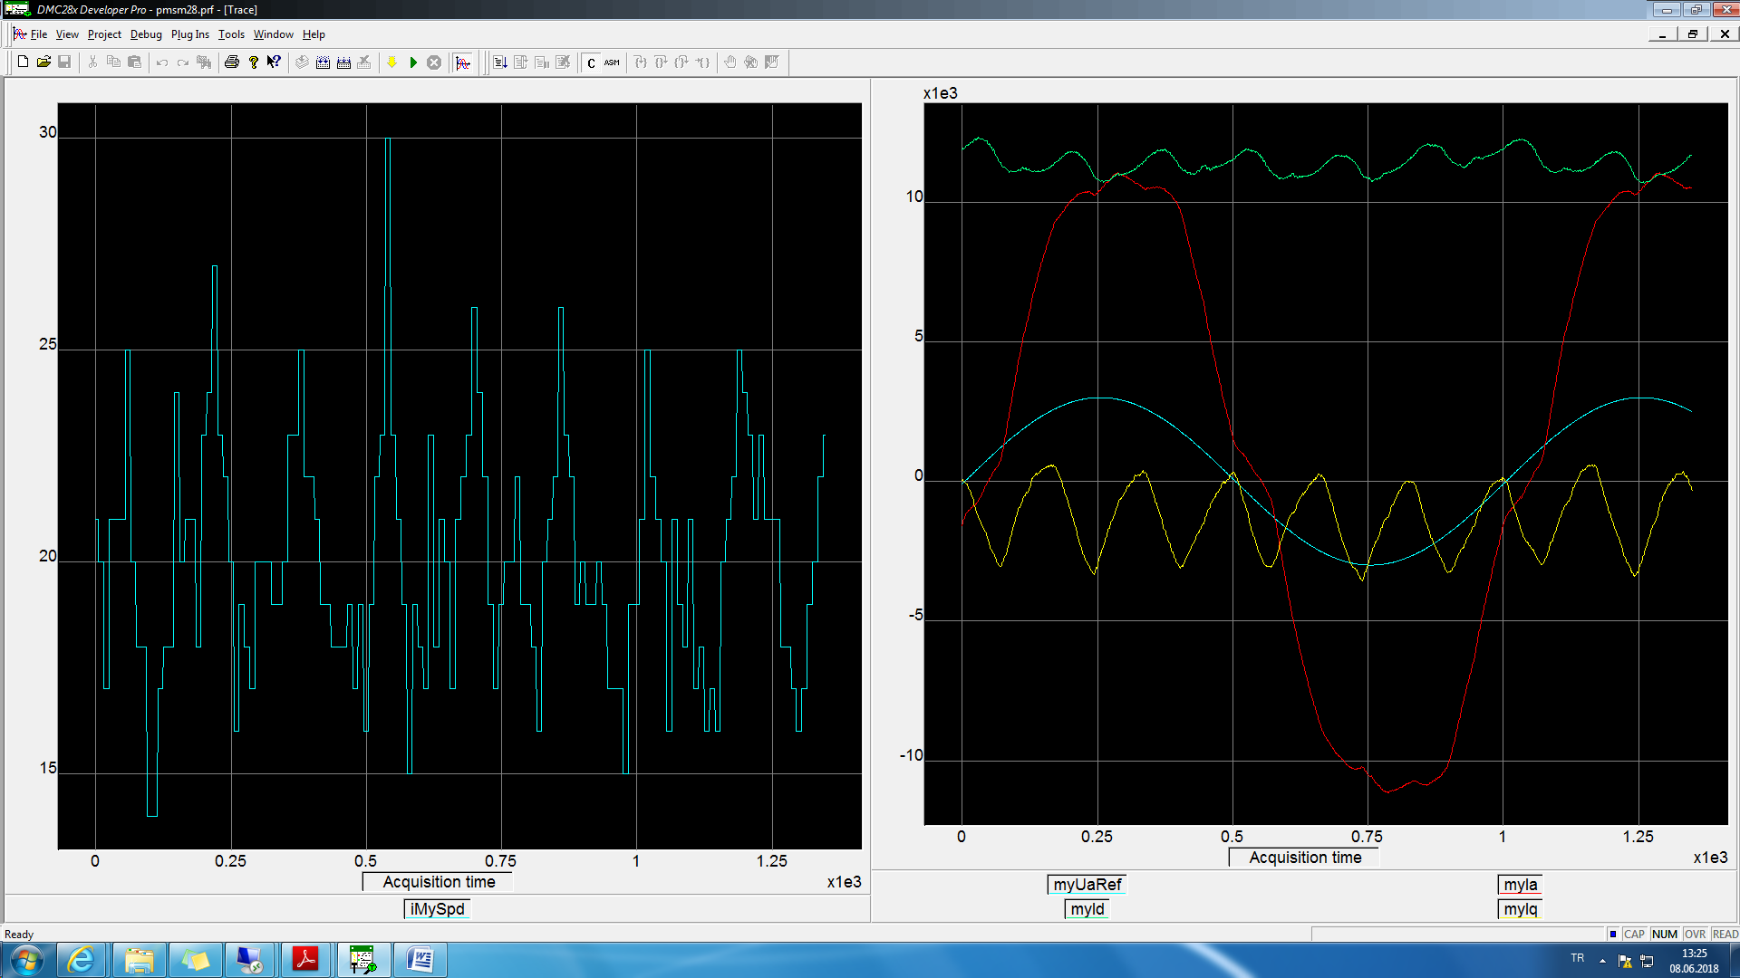

Figure 2 Left figure motor speed, right figure blue phaseA pwm reference, red phaseA, green Id, yellow Iq current @10Hz speed @open loop

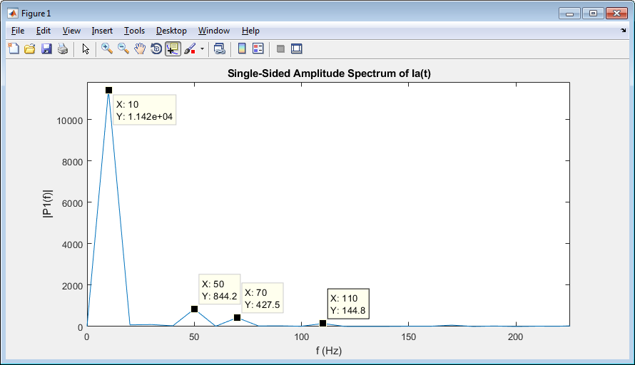

Figure 3 phaseA current, FFT analysis @10Hz speed @open loop

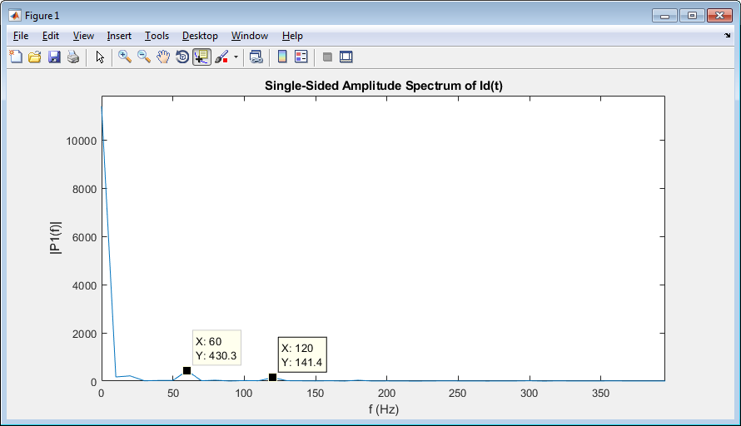

Figure 4 Id current, FFT analysis @10Hz speed @open loop

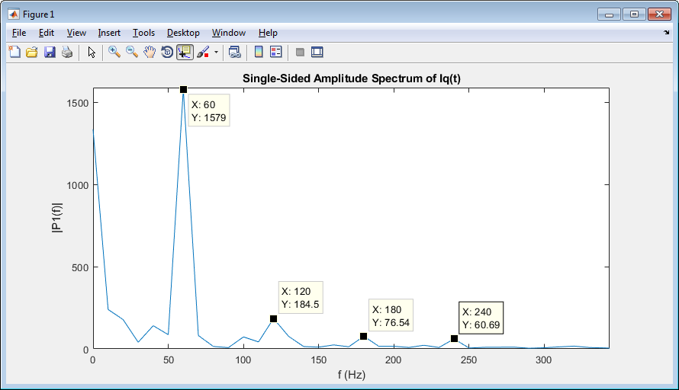

Figure 5 Iq current, FFT analysis @10Hz speed @open loop

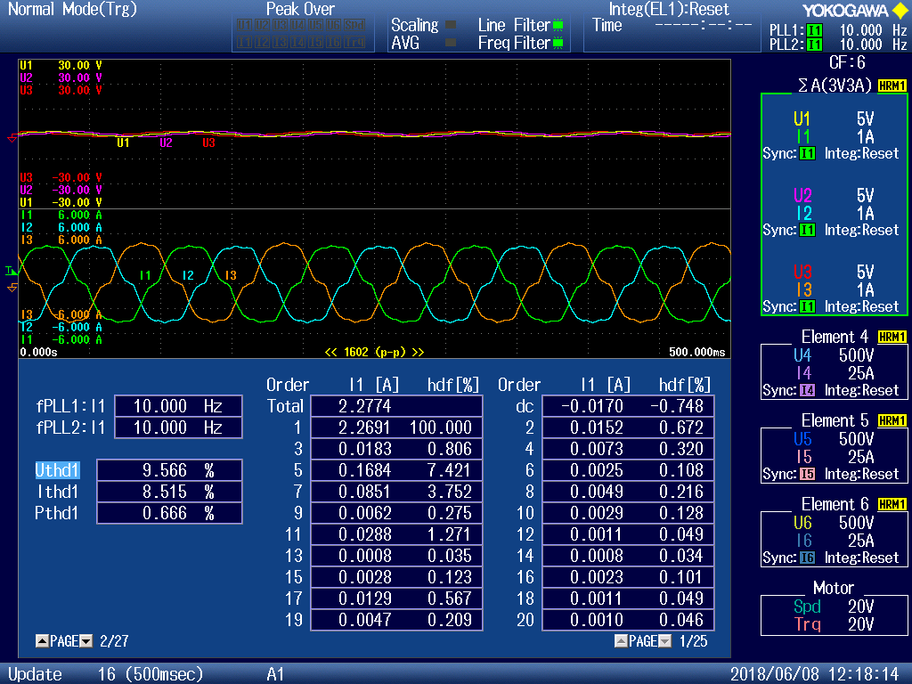

Figure 6 phase voltage and currents, and current harmonic distortions @10Hz speed @open loop

As can be seen above figures, nonlinear effects mainly produce 5th and 7th harmonics in the phase current, 6th and its multiples harmonics in the d-q reference frame currents.

As the output frequency increases i.e. speed increases, current distortion decreases which can be seen below figure. (Ithd1 is decreased)

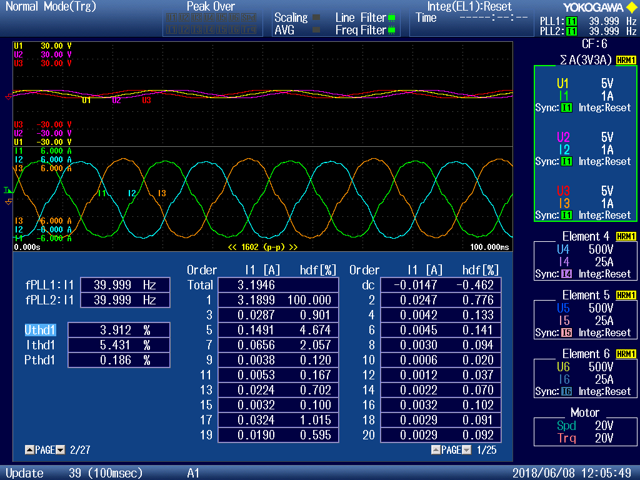

Figure 7 phase voltage and currents, and current harmonic distortions @40Hz speed @open loop

### Observation of relation between switching frequency fsw and nonlinearities

To observe effects of switching frequency on the nonlinearity, regular PI current control is used. To eliminate effect of the back emf voltage, iq\_ref is given zero. And to eliminate Ls effect id\_ref is varied so slow then only remains Rs value. Ideal case for required id current you need Ud which equals Ud = Rs \* id at this situation. But due to nonlinearities this equation is not linear. So the control performance and stability of the system will be degraded substantially.

Especially at zero crossing regions of id current, nonlinearities can be seen more easily. As the switching frequency increases, nonlinearities get more severe as can be seen below id and Ud figures.

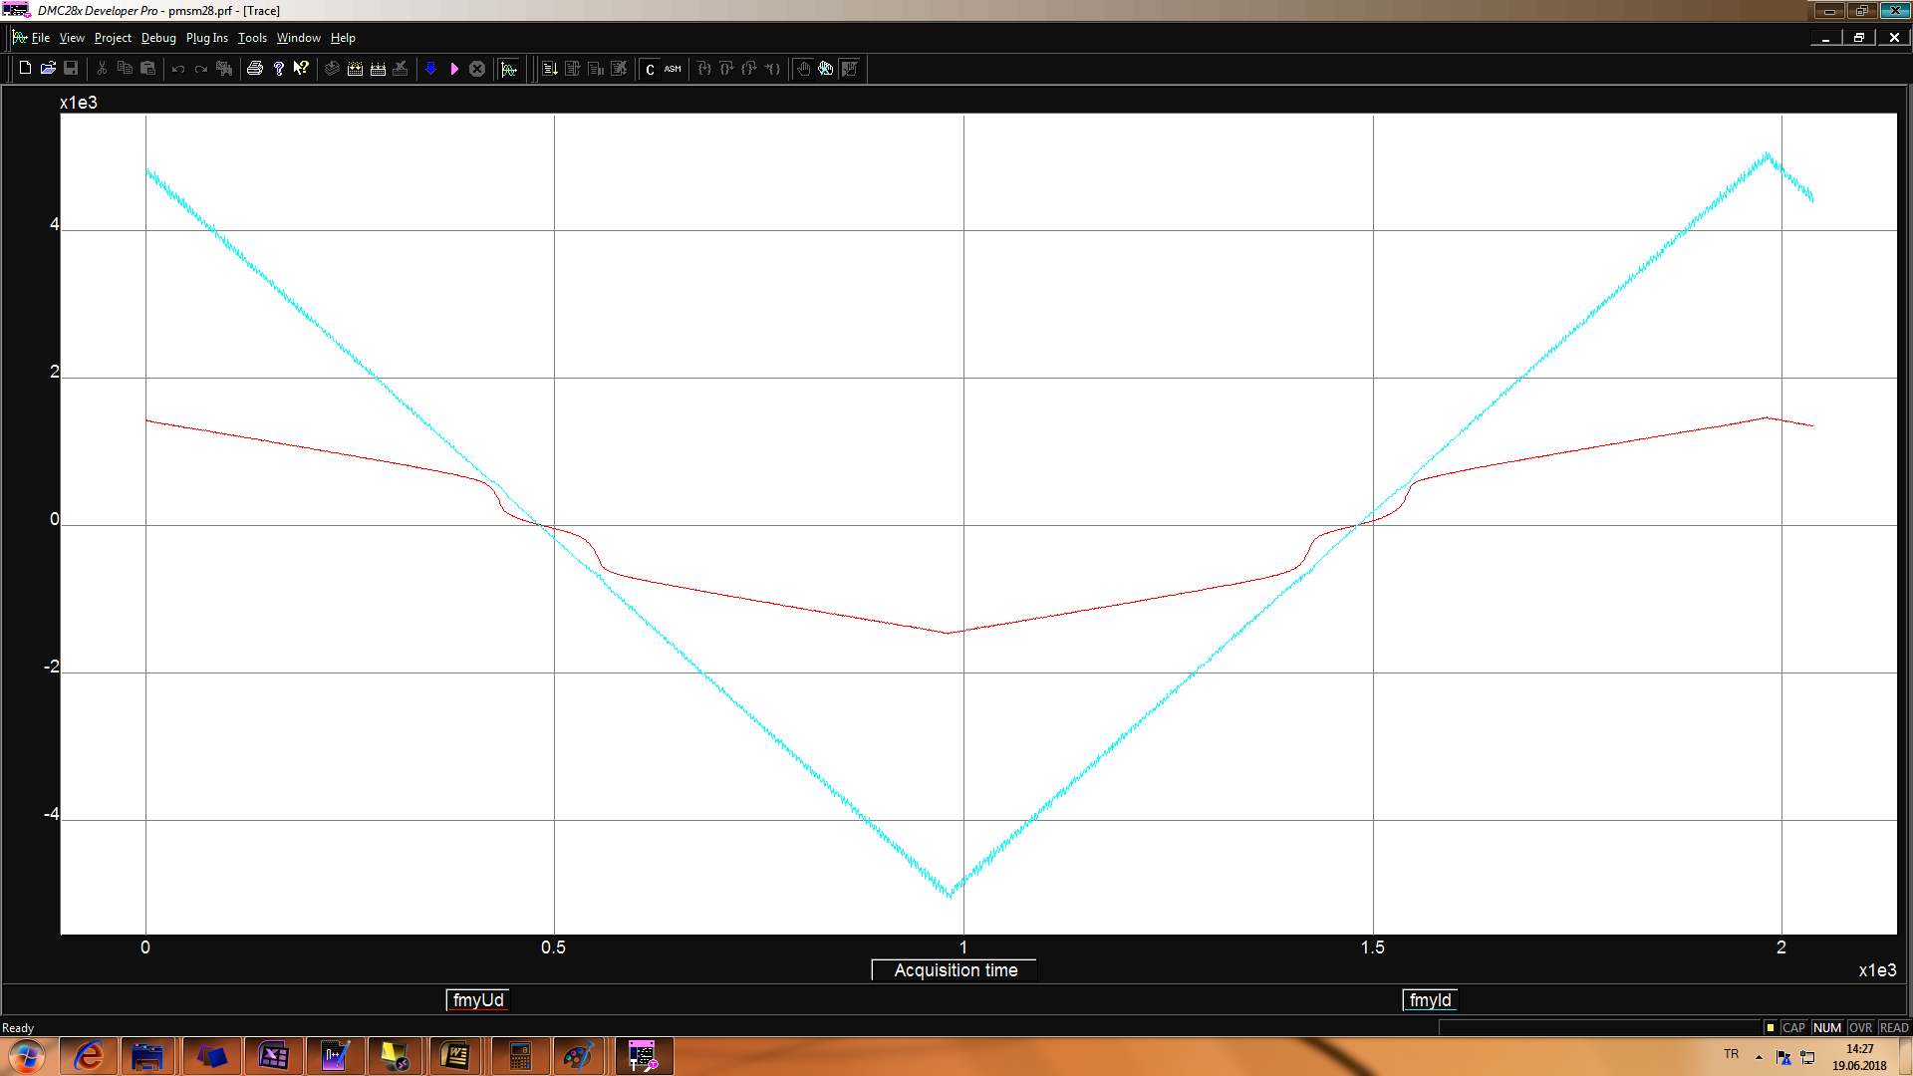

Figure 8 blue Id current and red Ud voltage, @fsw=10kHz @current loop

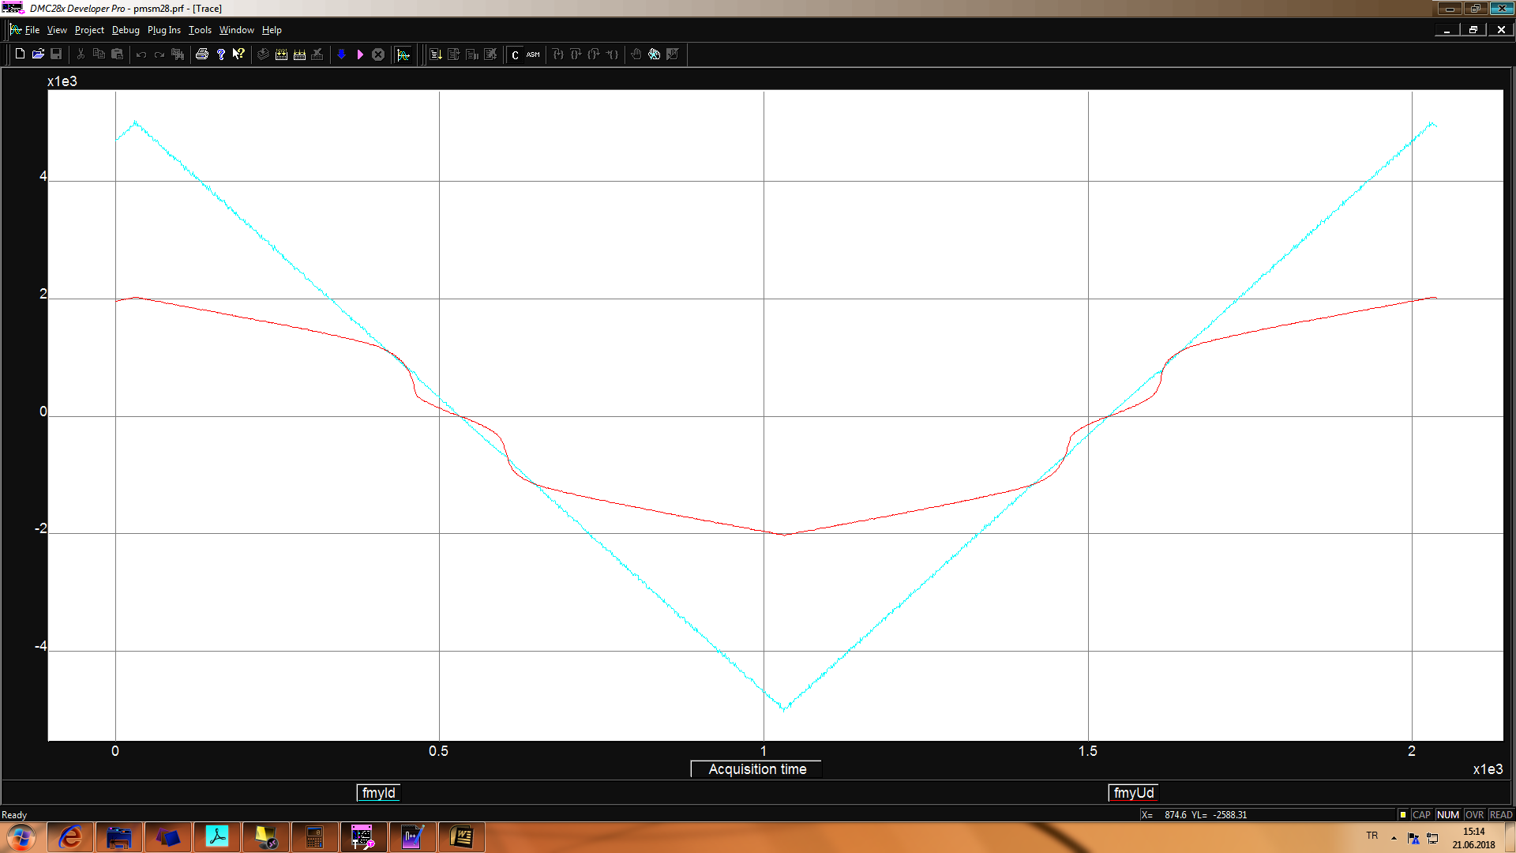

Figure 9 blue Id current and red Ud voltage, @fsw=20kHz @current loop

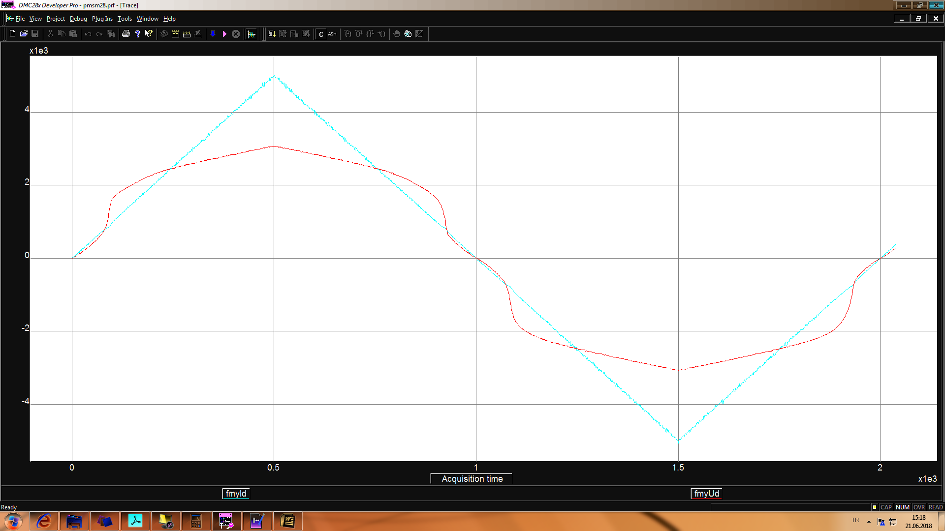

Figure 10 blue Id current and red Ud voltage, @fsw=40kHz @current loop

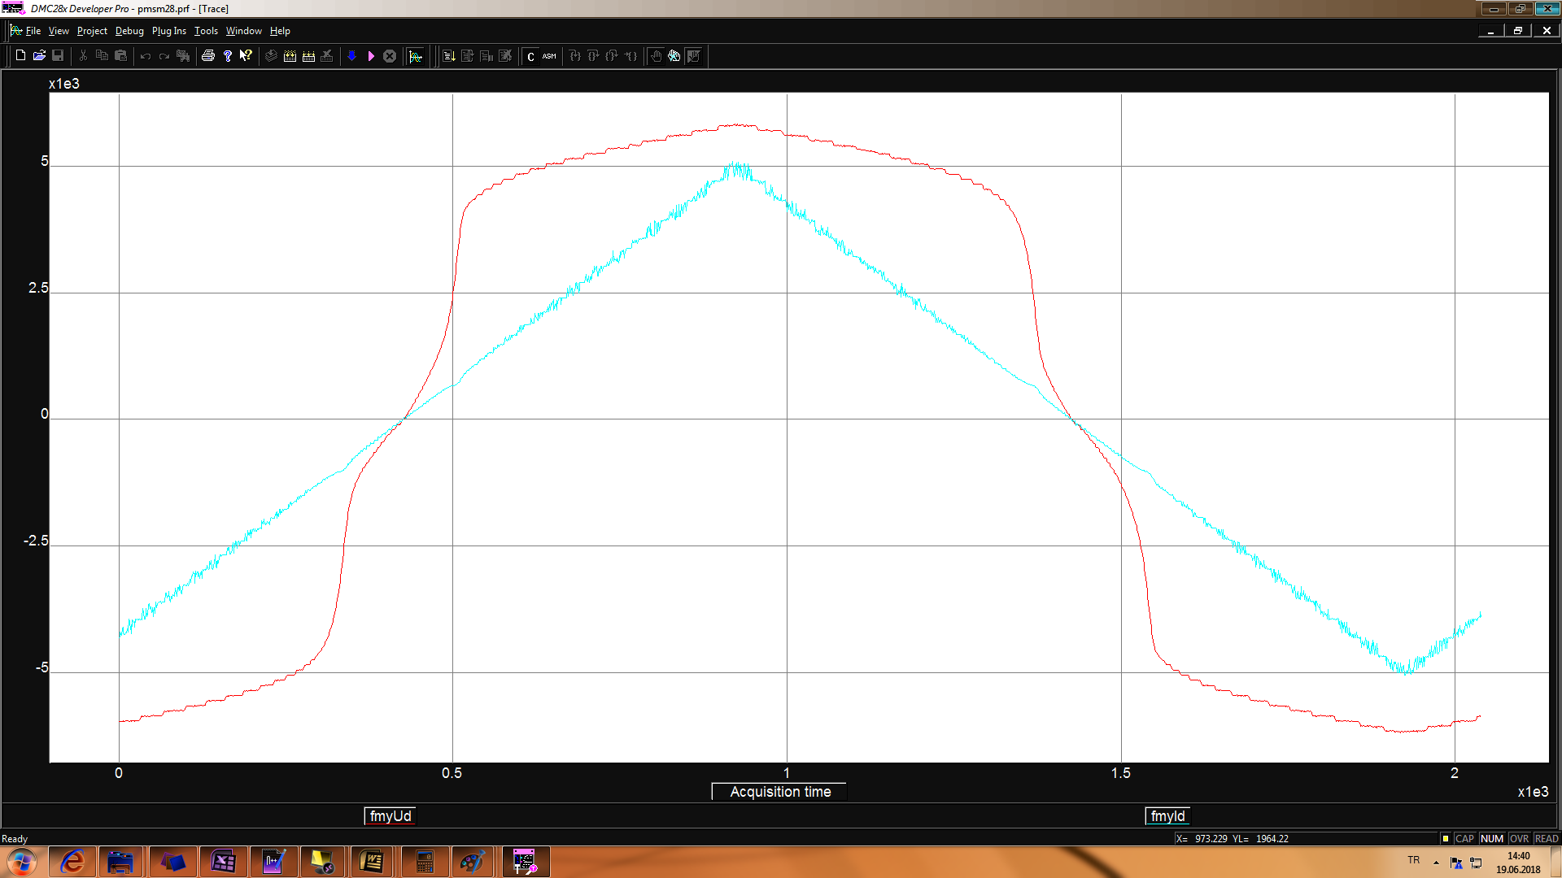

Figure 11 blue Id current and red Ud voltage, @fsw=100kHz @current loop

### Determination of f(id) to get Ud in MATLAB

To find function of id f(id) the measured Id & Ud values are used which are taken at 20kHz switching frequency.

 

Figure 12 Id & Ud graphs @fsw=20kHz @current loop

Ud vs Id graph is separated into pieces of parts, and curve fitting is applied to each parts to find f(id). As can be seen below figure



Figure 13 Id & Ud graph, pieces of parts @fsw=20kHz @current loop

After applying these curves to the original measurements following figure is obtained.



Figure 14 Id & Ud graph, fitted curves @fsw=20kHz @current loop

As can be seen above figure if there exist no nonlinearity, these two lines will be come to one line and it will be crosses the origin.

### Compensation of nonlinearity by using look up table of Id vs Ud graph in Simulink

If nonlinearity is compensated by using f(id) to get Ud voltage, id controller output will see only Rs as given below figures.

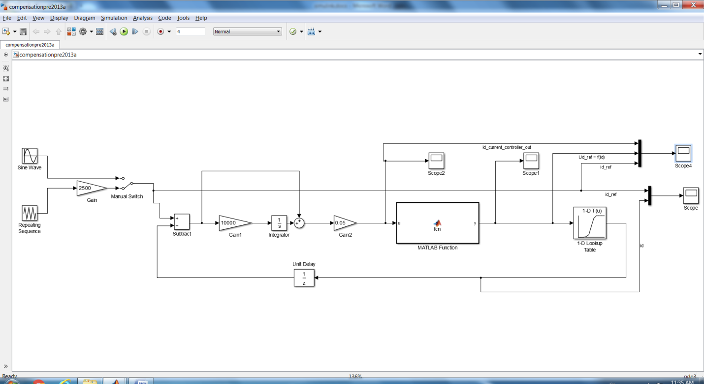

Figure 15 simulink model, nonlinearity is compensated by using f(id)

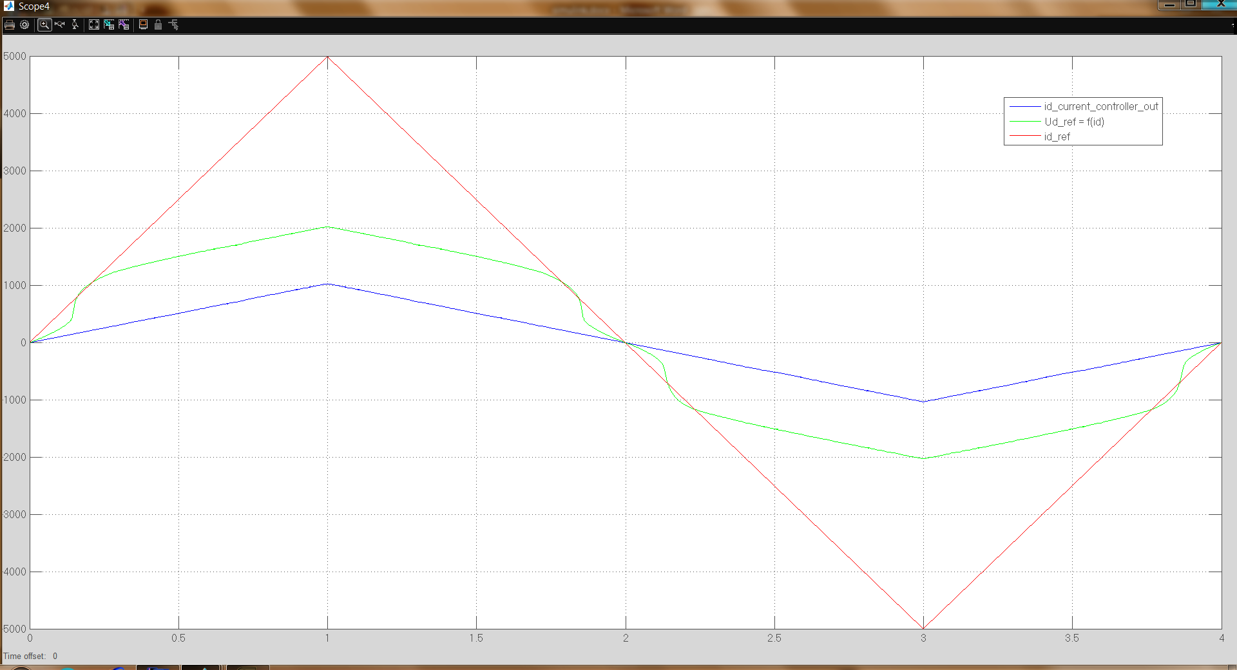

Figure 16 simulation data, red id\_ref, green f(id), blue id controller output, nonlinearity is compensated by using f(id)

10hz sine wave is given as id\_ref, nonlinearity is compensated.

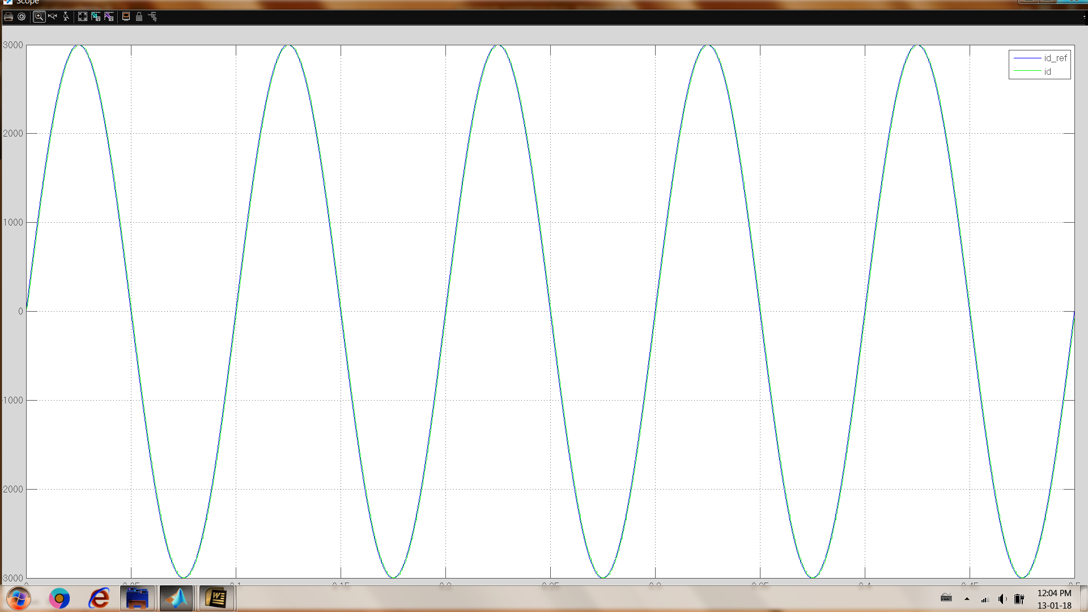

Figure 17 simulation data, blue id\_ref, green id, nonlinearity is compensated, 10hz sine wave id\_ref

Below figure is taken without compensation

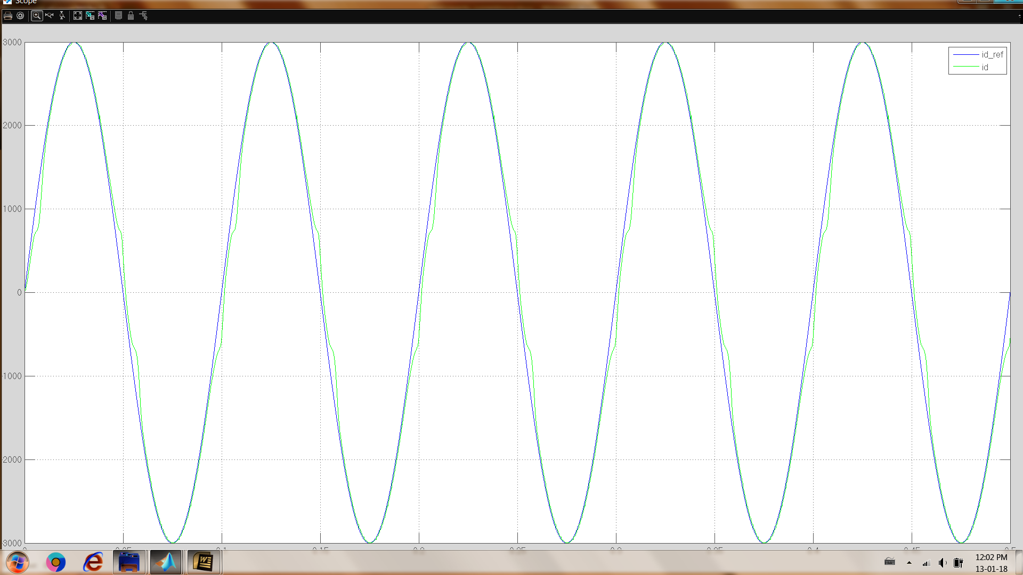

Figure 18 simulation data, blue id\_ref, green id, nonlinearity is not compensated, 10hz sine wave id\_ref

Simulation is repeated at 100Hz sine wave id\_ref

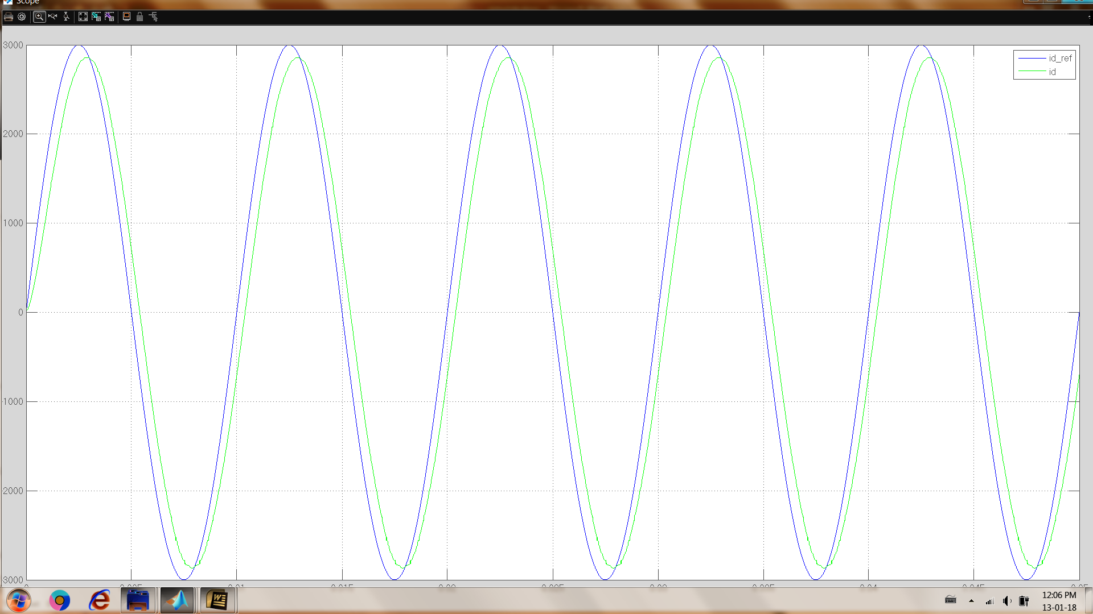

Figure 19 simulation data, blue id\_ref, green id, nonlinearity is compensated, 100hz sine wave id\_ref

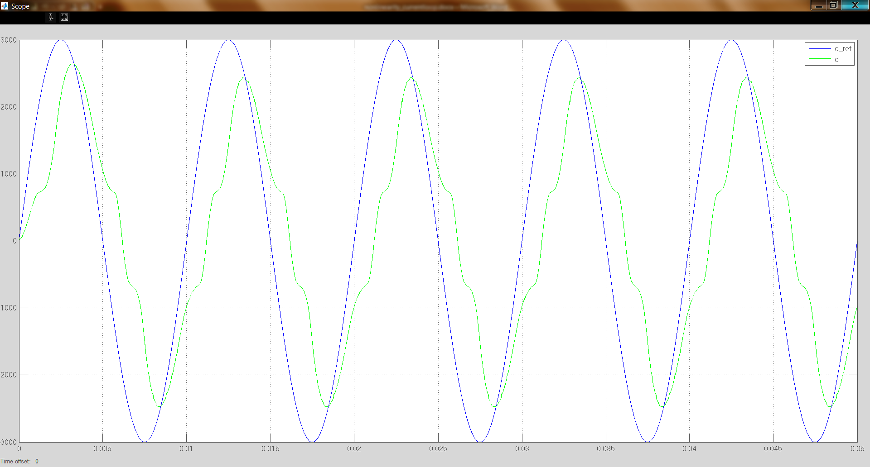

Figure 20 simulation data, blue id\_ref, green id, nonlinearity is not compensated, 100hz sine wave id\_ref

with compensation, bandwidth of the current controller is also increases as can be seen below bode diagrams.

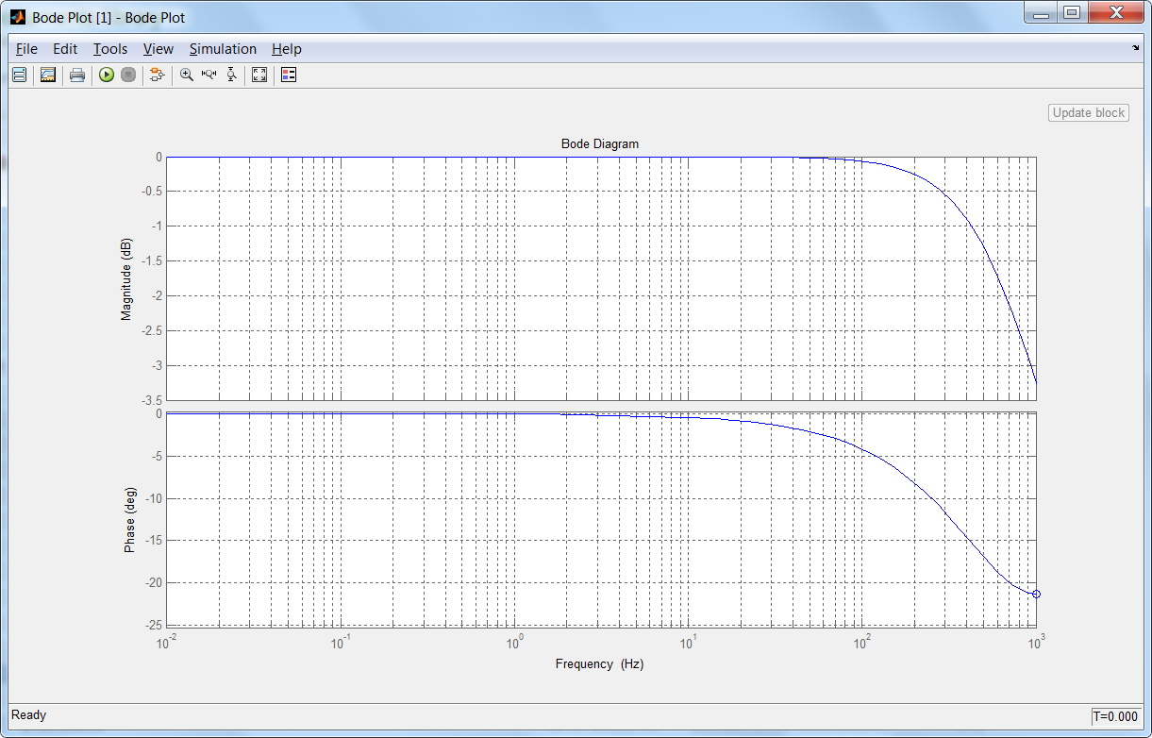

Figure 21 bode diagram of current controller, with nonlinearity compensation

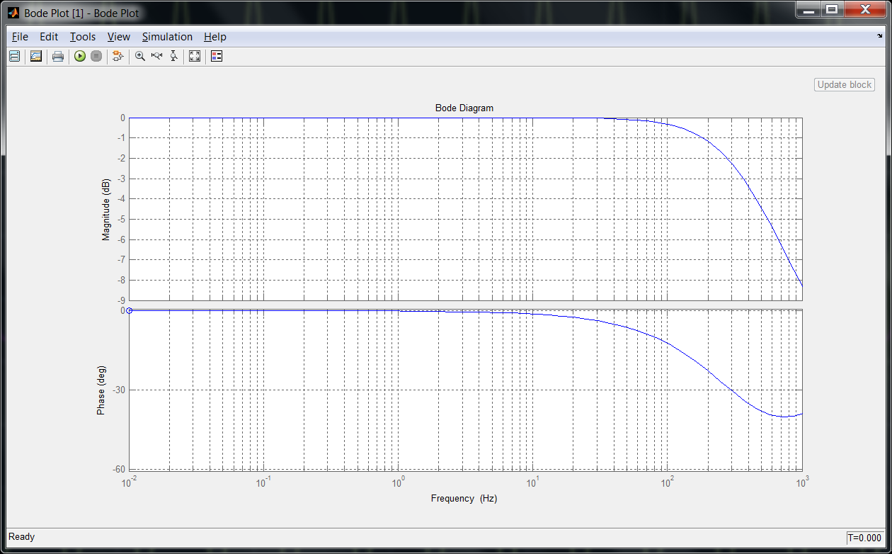

Figure 22 bode diagram of current controller, without nonlinearity compensation

### Experimental results of the compensation of nonlinearity

Similar tests are repeated by experimentally. 10Hz sine wave Id\_ref is applied with and without compensation of nonlinearity by using f(id)

D:\hyuruk\deneme\ec4pole\speed_test_index\compansated_step2_Kp_onethird_10Hz.wmf

Figure 23 experimental data, orange id\_ref, red id, blue f(id) nonlinearity is compensated, 10hz sine wave id\_ref

D:\hyuruk\deneme\ec4pole\speed_test_index\notcompansated_step_Kp_onethird_10Hz.wmf

Figure 24 experimental data, orange id\_ref, red id, nonlinearity is not compensated, 10hz sine wave id\_ref

D:\hyuruk\deneme\ec4pole\speed_test_index\compansated_step_Kp_onethird_100Hz.wmf

Figure 25 experimental data, orange id\_ref, red id, blue f(id), nonlinearity is compensated, 100hz sine wave id\_ref

D:\hyuruk\deneme\ec4pole\speed_test_index\notcompansated_step_Kp_onethird_100Hz.wmf

Figure 26 experimental data, orange id\_ref, red id, nonlinearity is not compensated, 100hz sine wave id\_ref

### Difficulties to get f(id) for compensating nonlinearities

Fractions of the fitted curve functions effects the results which can be seen below figure.



Figure 27 one of the piece of parts red measured data, only fractions different between blue and yellow fitted curves

Sample rate of the data log effects the Id vs Ud graph which can be seen below figure.



Figure 28 blue 1ms per sample, green 0.5ms per sample, Id vs Ud graphs with different sample rates

Input voltage value effects the Id vs Ud graph which can be seen below figure.



Figure 29 Id vs Ud graphs with different input voltage values

### How to increase current control bandwidth without compensation of nonlinearities

Dead-time, rise/fall time of the mosfet/gate driver, turn on/off delay time of the mosfet/gate driver are the most dominant terms in the nonlinearity. (for this MOSFET based VSI, dead-time is configured to 1.0us)

MOSFET SUM90N10 and gate driver irs2336D time values are given below

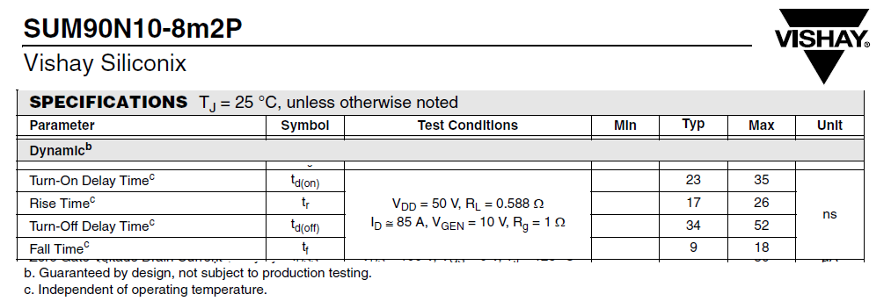

Figure 30 MOSFET SUM90N10 time specs

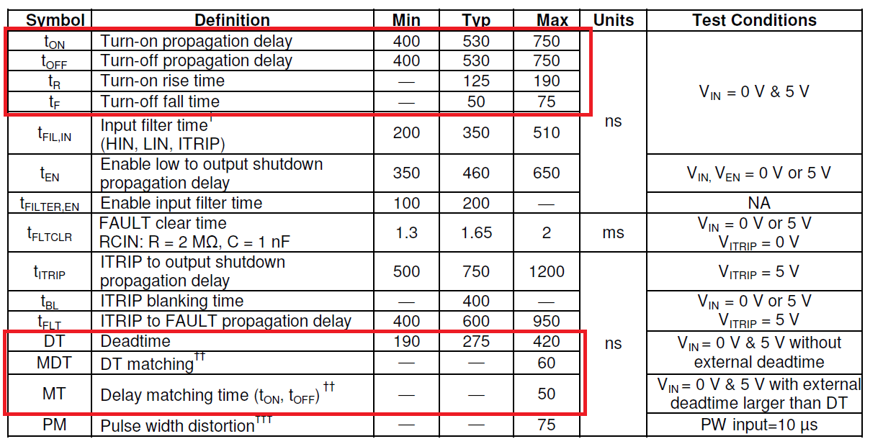

Figure 31 irs2336D time specs

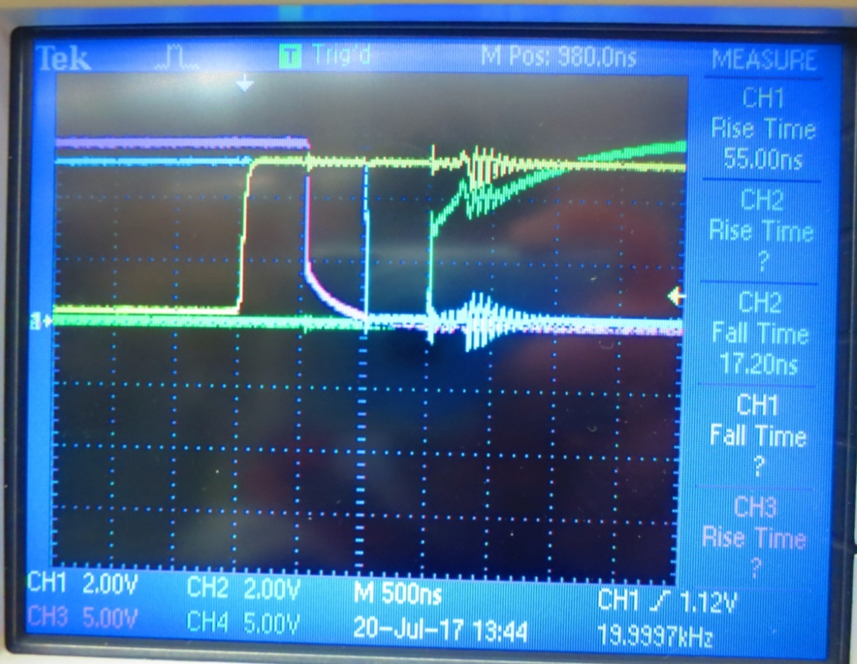 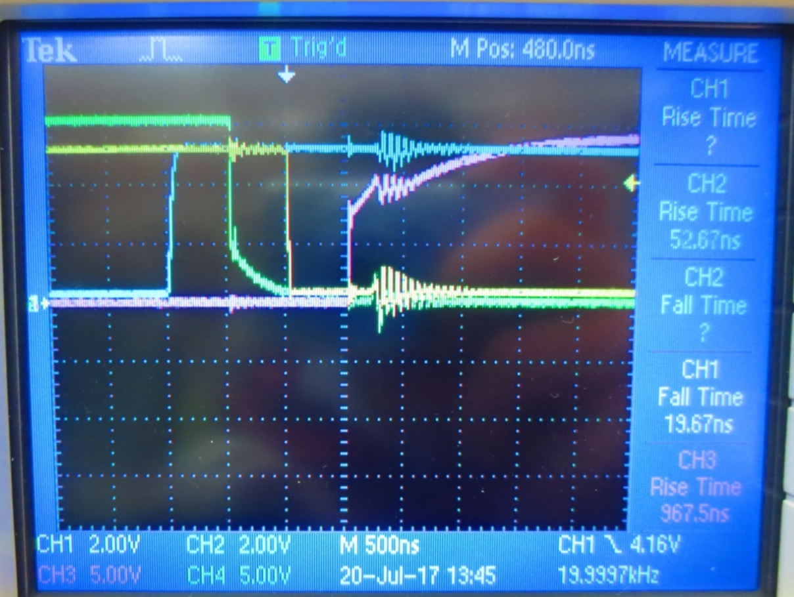

Figure 32 yellow PWMA\_VinHI, blue PWMB\_VinLO (gate driver inputs), pink Gate\_driver\_OUTA\_HI, green gate\_driver\_OUTB\_LO, irs2236(D) active low

Effect of these time parameters get more dominant as the switching frequency increases. For example dead-time 1us is the 1% of the switching period when fsw 10kHz, but it is 10% when fsw 100kHz.

Although these nonlinearity may be compensated by determining f(id) functions to increase bandwidth of the current controller, it is difficult to obtain valid f(id) for all input voltages, for all environmental conditions etc.

So, if a GaN transistor based VSI is used instead of the MOSFET based VSI, these time parameter values will decreases. So effect of these parameters on nonlinearity will also decreases.

## High bandwidth current control by using GaN transistor based VSI

Wide-bandgap (WBG) devices, such as GaN HEMTs and SiC MOSFETs are recently growing interest for the power electronics design. Compared to conventional Si MOSFETs or IGBTs, WBG devices exhibit shorter turn on/off time intervals, close-to-zero reverse recovery loss, better thermal capability and smaller conduction loss. These characteristics make it possible to increase the system switching frequency from ~hundreds of kHz to >MHz, which further results in the significant weight and size reduction of the power electronics

To get high current control bandwidth, switching frequency should be increased, but as stated previous chapters as the switching frequency increases, nonlinearity will also increases. To balance this situation GaN transistor based VSI are coming to interest. TI design three phase GaN inverter and F28379D LaunchPad is used for this application.

### Overview of the GaN transistor based VSI (BOOSTXL-3PHGANINV) ti design

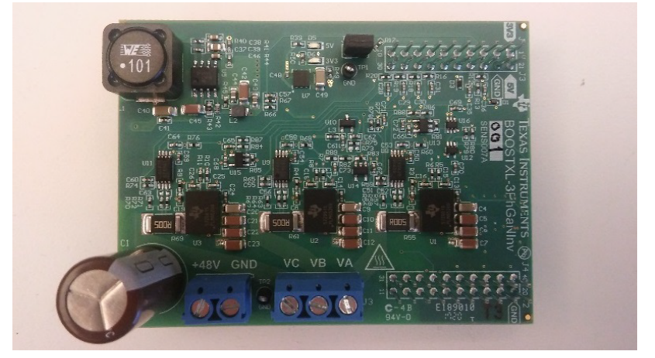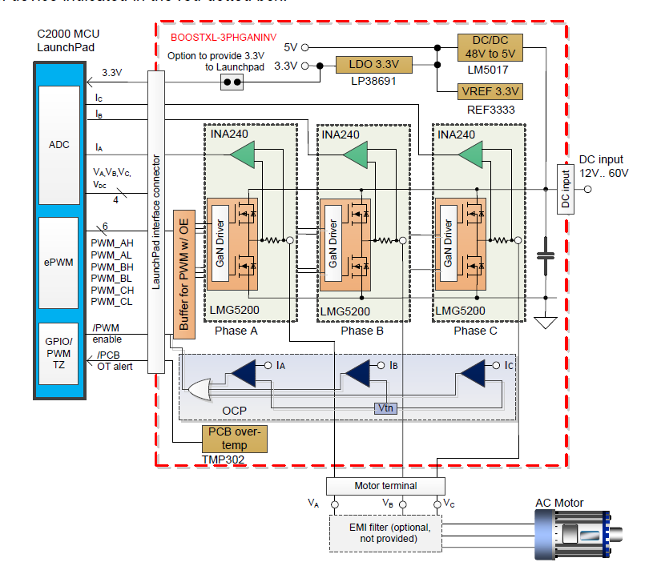

Figure 33 the BOOSTXL-3PhGaNInv EVM, three-phase GaN inverter

This EVM supports the following features:

• Wide input voltage range 12 V to 60 V

• LMG5200 GaN half-bridge power stage simplifies PCB layout and reduces parasitic inductances for optimized switching performance; less than 2ns rise and fall time

• Precision in-line phase current sensing with 5-mΩ shunt (for theoretical ±16.5-A full-scale range), and ±10-A peak nominal range for this EVM

• TI BoosterPack compatible interface with 3.3-V I/O for easy performance evaluation with C2000MCU LaunchPad Development Kit

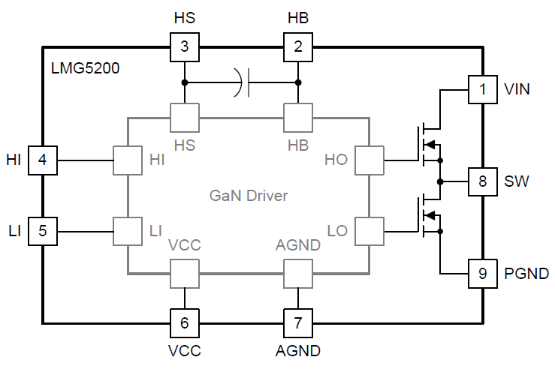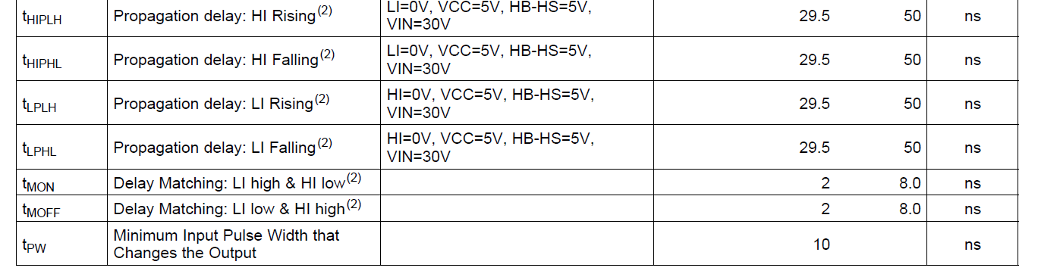

Figure 34 block schema and time specs of the LMG5200 integrated GaN HEMT and Driver half bridge

LMG5200 GaN half-bridge features

* Integrated 15-mΩ GaN FETs and Driver
* 80-V Continuous, 100-V Pulsed Voltage Rating
* Very Low Common Source Inductance to Ensure High Slew Rate Switching Without Causing Excessive Ringing in Hard-Switched Topologies
* Gate Driver Capable of Up to 10 MHz Switching
* Internal Bootstrap Supply Voltage Clamping to prevent GaN FET Overdrive
* Excellent Propagation Delay (29.5 ns Typical) and Matching (2 ns Typical)

### Measurements with the GAN transistor based VSI (BOOSTXL-3PHGANINV)

Switching characteristics of the LMG5200 is given following figures. Dead-time is settled to 50ns in this experiment.

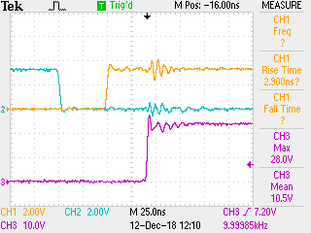 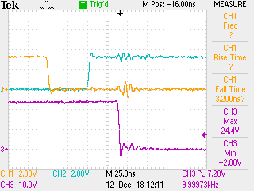

Figure 35 blue input pwm\_LO, orange input pwm\_HI, purple SW of the LMG5200 GaN half bridge @10kHz fsw

For this example dead-time 50ns is the 0.05% of the switching period when fsw 10kHz and it is 0.5% when fsw 100kHz.

### Current control bandwidth measurements of the GAN transistor based VSI (BOOSTXL-3PHGANINV)

For this application following test setup is prepared, one motor is the driver motor and the other is the load motor. The same air cored motor is used for this application. Harmonic drive PMG gearbox is connected to motor for coupling and loading purposes. These motor is driven by two GaN based VSI and C2000™ LAUNCHXL-F28379D LaunchPad is used for controller.

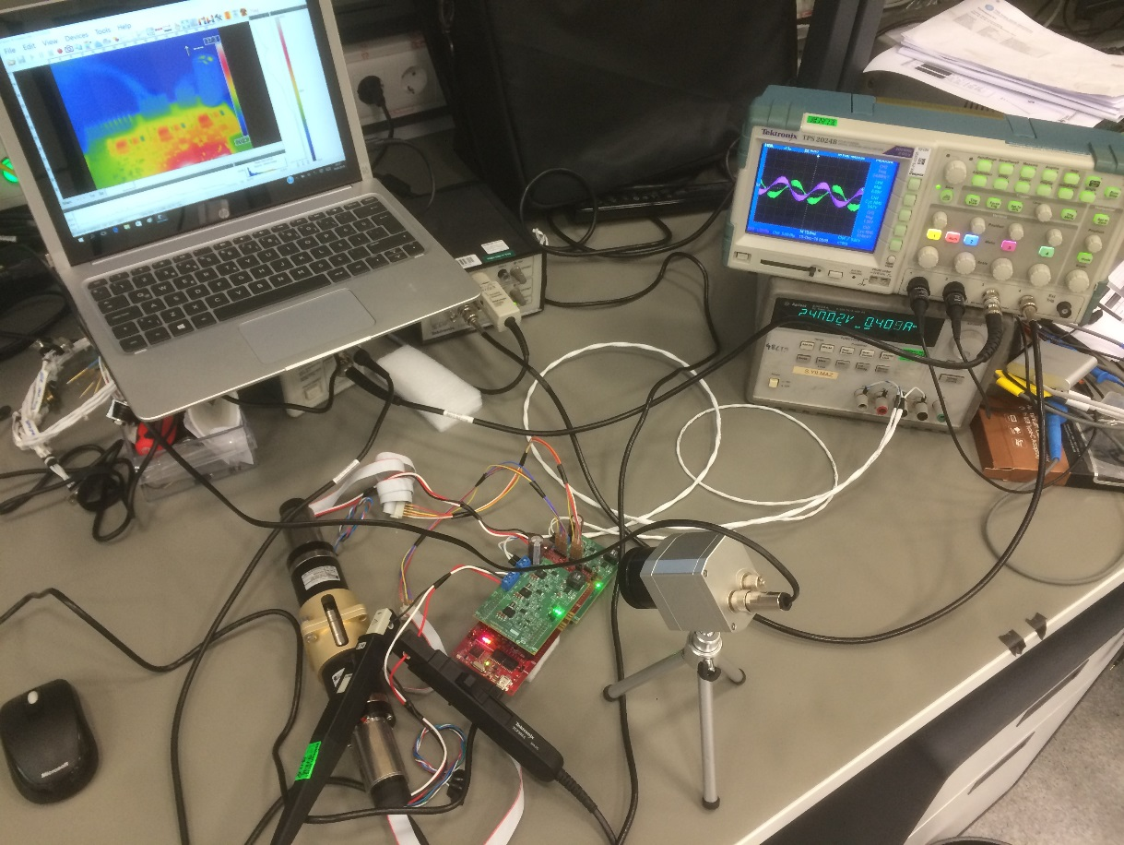

Figure 36 experimental setup for GaN based VSI with the air cored servo motor

Texas Instruments' Software Frequency Response Analyzer (SFRA) library is used for frequency response analysis of the open loop characteristics of the current id & iq closed loop system. This can be done with no external connections or equipment is required. It can also be used to get stability information such as the gain margin, phase margin and bandwidth to evaluate the control loop performance.

Motor1 is used as driver motor which maintains the shaft to the reference speed by speed controller. Motor2 is used as load motor and this motor is used for SFRA. Speed reference is given as 25Hz. Effective switching frequency is doubled by double sampling method. Fast current loop FCL ti library is used for current control. Target current control bandwidth for id and iq loop is configured as fsw/6. Measurements of the open loop characteristics of the current id & iq closed loop system are given following figures

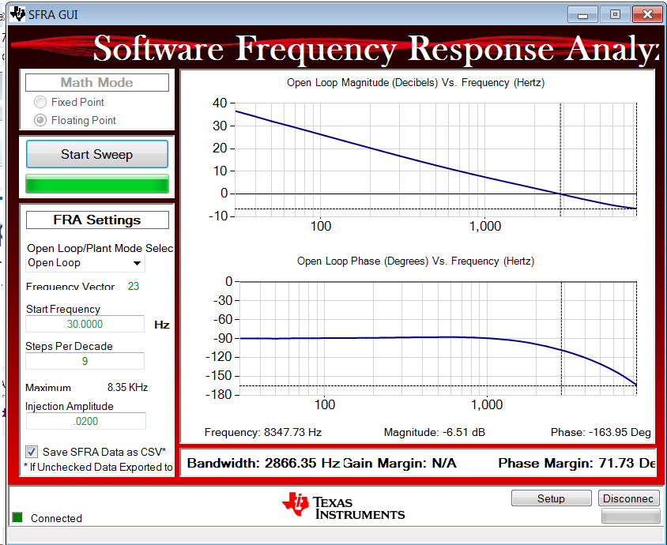

Figure 37 frequency response of the open loop characteristics of the current id closed loop system @20kHz fsw

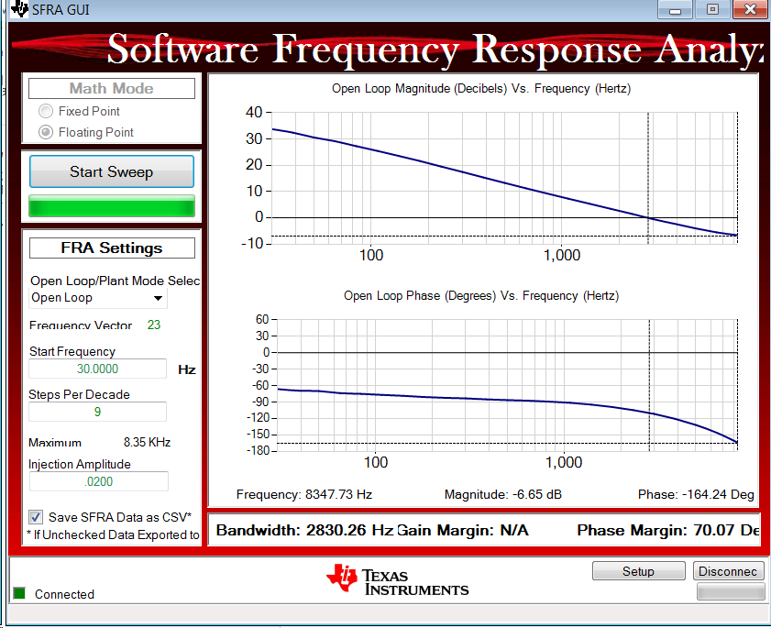

Figure 38 frequency response of the open loop characteristics of the current iq closed loop system @20kHz fsw

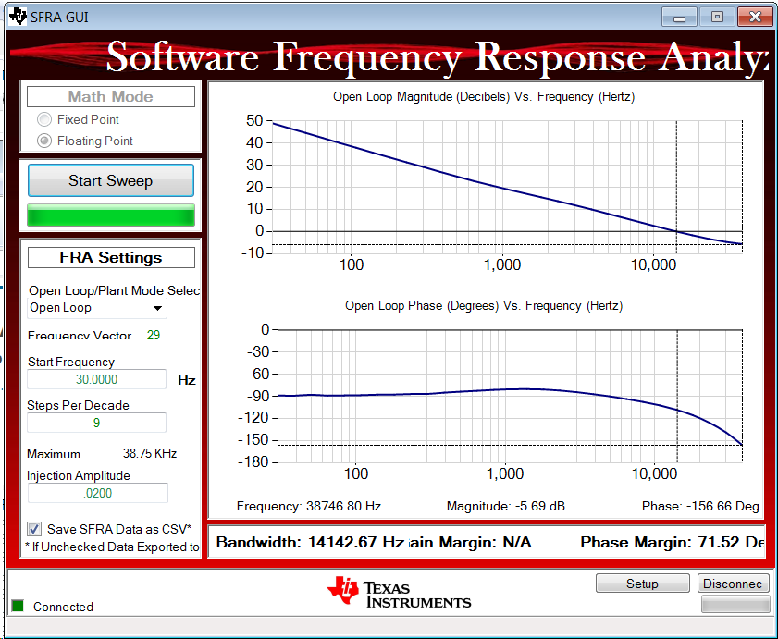

Figure 39 frequency response of the open loop characteristics of the current id closed loop system @100kHz fsw

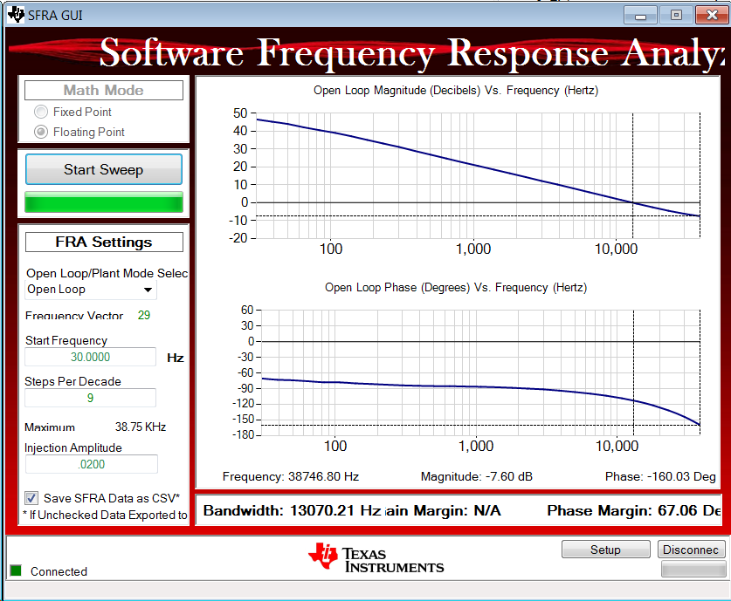

Figure 40 frequency response of the open loop characteristics of the current iq closed loop system @100kHz fsw

## Future plan

Low inductance motors which are designed by removing iron teeth from a motor stator or making an air core actuator allows for unique form factors, smooth motion, high efficiency, fast response, detent free, good heat dissipation, high overload capacity and good Kt linearity. But on the other hand, low inductance values can lead to control loop instabilities, inaccuracies in current readings, increased power losses and other problems. So to cope with these problems switching frequency should be higher so that current control bandwidth will be also high.

GaN transistor based VSI is planning to design to get high current control bandwidth. Since the current loop is the inner most of the control loop, it enables the outer speed and position loops to be faster for servo motor drive. This high performance servo motor drive can be used applications such as pedestal, robot arm, optic stabilizer, CNC machines, active vibration canceller etc. It will be also used to drive low inductance motors.

While designing the layout of the GaN based VSI, some software tools are planning to use to determine layout parasitic inductances of the PCB layout. Wide band gap devices enable a higher switching frequency and higher edge speeds (the “di/dt” of the switched loop). For this reason simulating these parasitic inductances while designing layout, gets more important issues.